A CRM APPLICATION FOR SCHOOLS AND COLLEGES

# INTRODUCTION:

## 1.1. OVERVIEW:

The project aim is to provide real time knowledge for all the students who have basic knowledge of sales force and looking for real time project. This project will also help those professionals who are in close technology and want to switch to sales force.

Customer relationship management [CRM]:

This is a tool with immense values. CRM is the customer centric centric system that can help educational professionals, nurtre relationship with prospects. A CRM software offers a wide range of applications to help you manage and interact with leads, with different systems including a variety of different system. However there are few common functions that most CRMs will include: contact management, team management, communication tool and reporting.

## 1.2. PURPOSE OF CRM:

A good customer relationship management platform is the backbone of many successful students recruitment efforts. It gets helps us organized and see customer data in one place. It boost customer loyality. And it increase colloboration between teams. Another main purpose of customer relationsip management is to reduce cost by managing costly complaints . A customer relationship management enables a business to cut cost and increase profit

# PROBLEM DEFINITION & DESIGN THINKING:

## 2.1. EMPATHY MAP:

A empathy map is a template that organizes a users behaviours and feelings to create a sense of empathy between the user and your team.

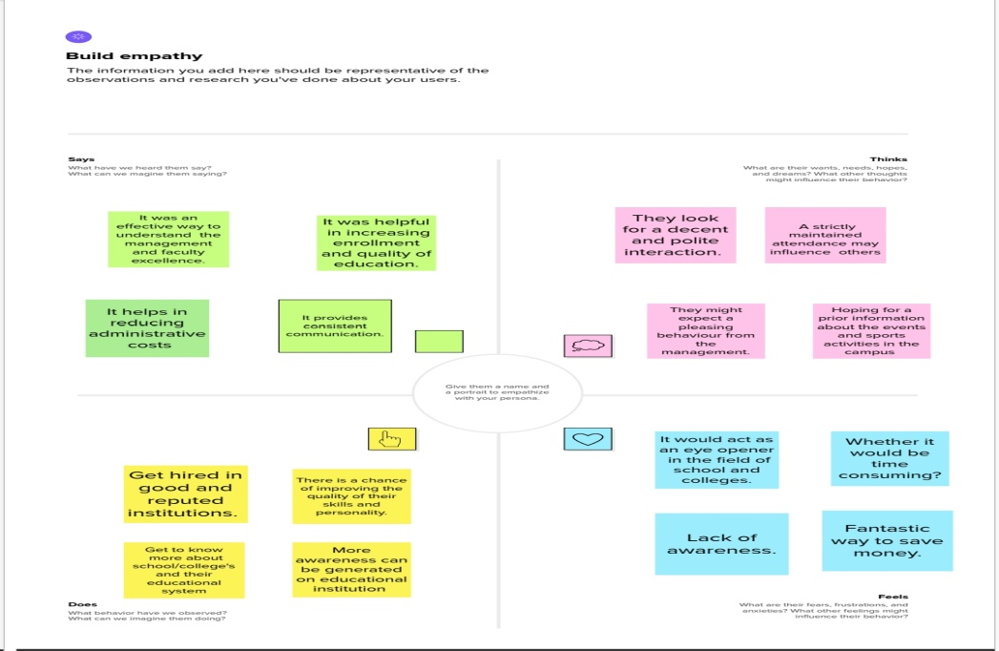

## 2.2. IDEATION AND BRAINSTORMING MAP:

Ideation is often closely related to practice of brainstorming, a specific technique that is utilized to generate new ideas. A principle difference between ideation and brainstorming is that ideation is commonly more thought of as being an individual pursuit, while brainstorming is almost always a group activity. Ideation is a process of forming ideas from conception to implementation, most often in an business setting.

Brainstorming is a group problem solving method that involves the spontaneous contribution of creative ideas and solution.

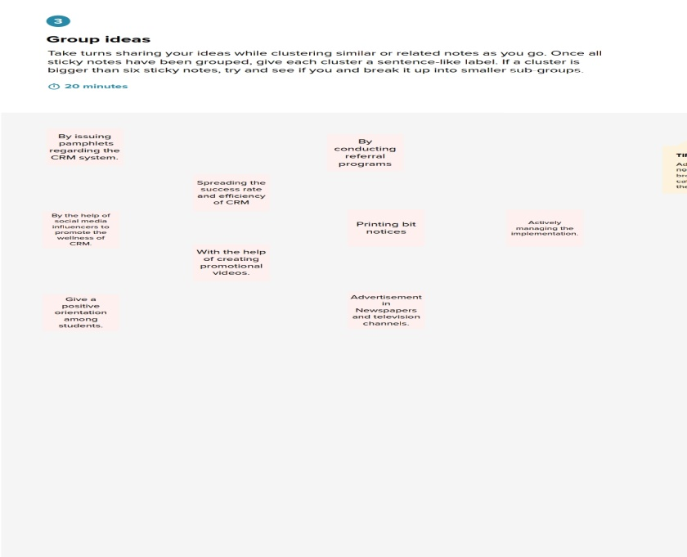

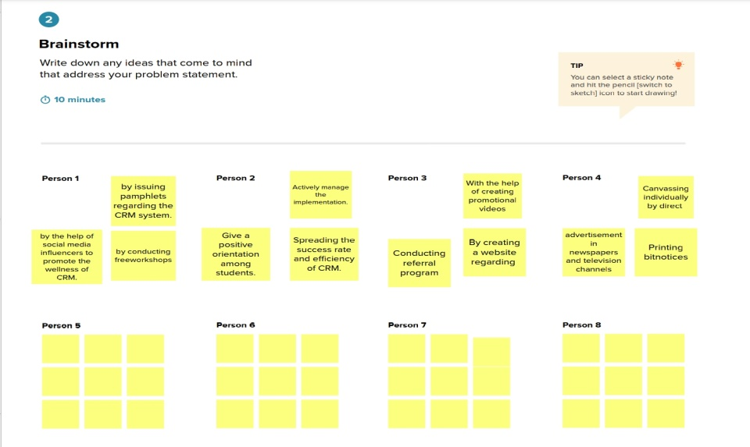

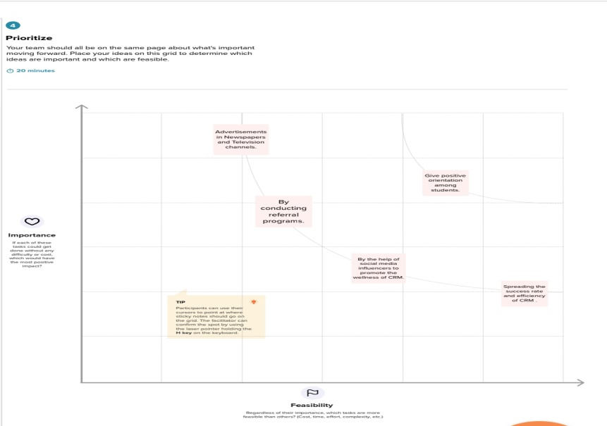

# RESULT:

## 3.1. DATA MODEL:

|  |  |  |
| --- | --- | --- |
| OBJECT NAME | FIELD LABEL | DATA TYPE |
| SCHOOL | ADDRESS | TEXT AREA |
| STUDENT | PHONE NUMBER | PHONE |
| PARENT | PARENT ADDRESS | TEXT AREA |

## 3.2. ACTIVITY & SCREENSHOT:

### MILESTONE 1\_CREATING A SALESFORCE ACCOUNT:

#### SALESFORCE:

Salesforce is your customer success platform designed to help you sell, service, market, analyze, and connect with your customers . It also helps and has everything needed to run a business from anywhere. World’s #1 customers relationships platform, we help your marketing, sales, commerce service and IT, teams work as one from anywhere so you can keeo you customers happy everywhere.

### Creating sales force account:

By using the link salesforce.developers.com, the account is created. And it has to be logged in to perform the below mentioned activities.

## MILESTONE 2\_OBJECT:

Salesforce objects are database tables that permit you to store data that is specific to an organization. salesforce objects are two types: Standard objects are the kind of objects that are the kind of objects that are provided by salesforce.com such as users, contracts, reports, dashboards,etc.

## ACTIVITY-1: CREATION OF SCHOOL OBJECT

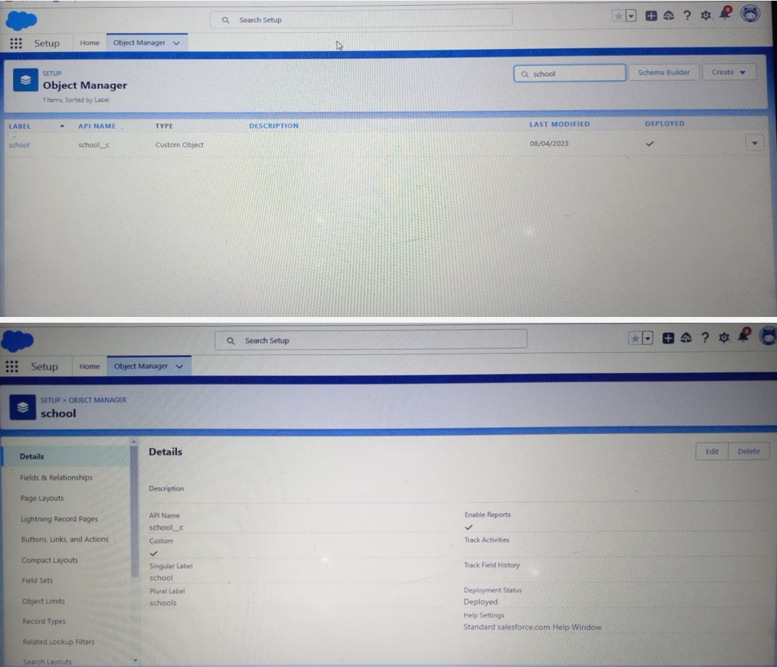

## ACTIVITY-2:CREATION OF STUDENT OBJECT

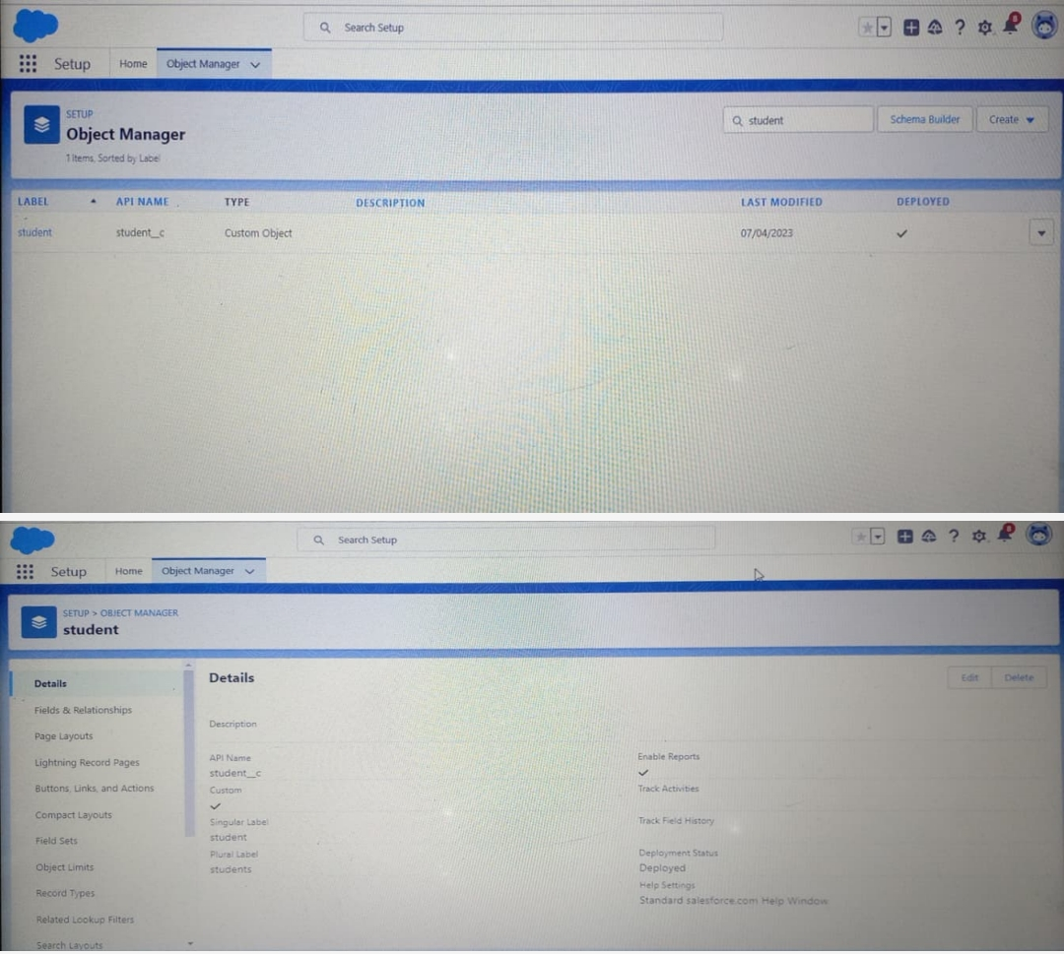

## ACTIVITY-3:CREATION OF PARENT OBJECT

# C:\Users\Admin\Downloads\Screenshot_2023-04-12-00-31-38-81_4a24d271e133915ae237d4bec6ffe368.jpg

# MILESTONE-3: LIGHTNING APP

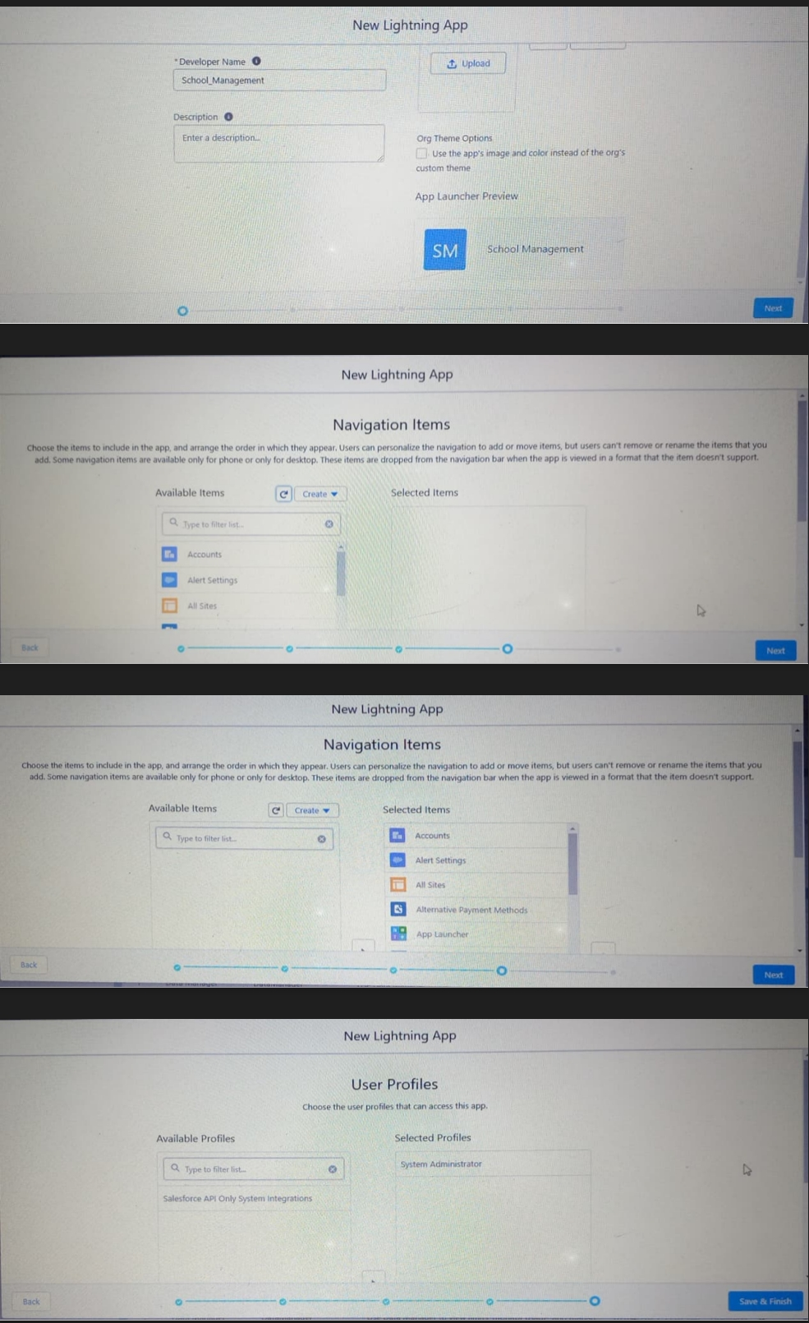

# MILESTONE -4: FIELDS AND RELATIONSHIP

## ACTIVITY-1: CREATION OF FIELDS FOR THE SCHOOL OBJECTS

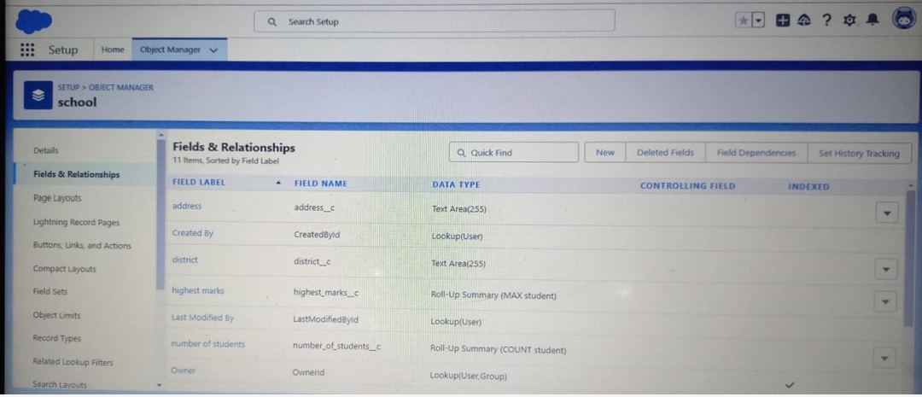

## ACTIVITY-2: CREATION OF FIELDS FOR THE STUDENT OBJECTS

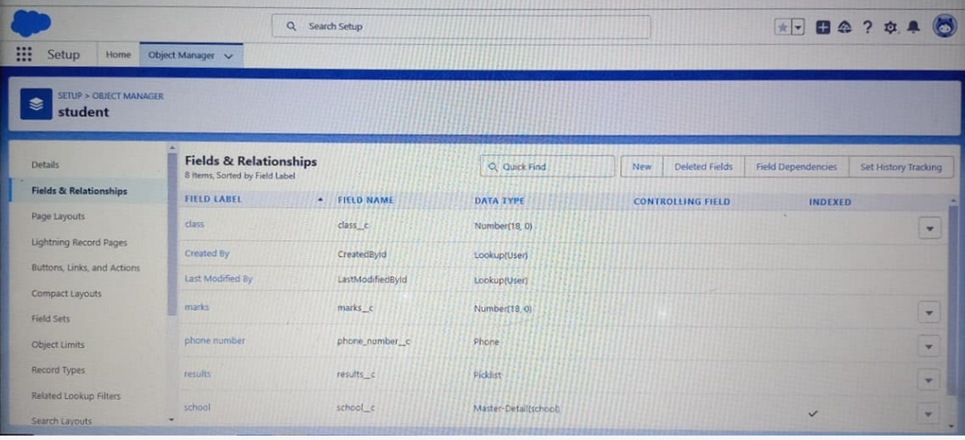

## ACTIVITY-3: CREATION OF FIELDS FOR THE PARENT OBJECTS

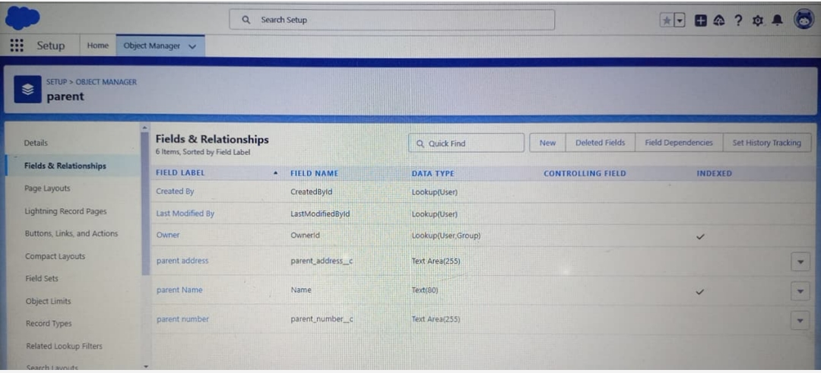

# MILESTONE-5: PROFILE

A profile is a group/collection of settings and permissions that define what a user can do in salesforce. A profile controls “object permissions, fields permissions, user permissions, tab settings, app settings, apex class records etc…

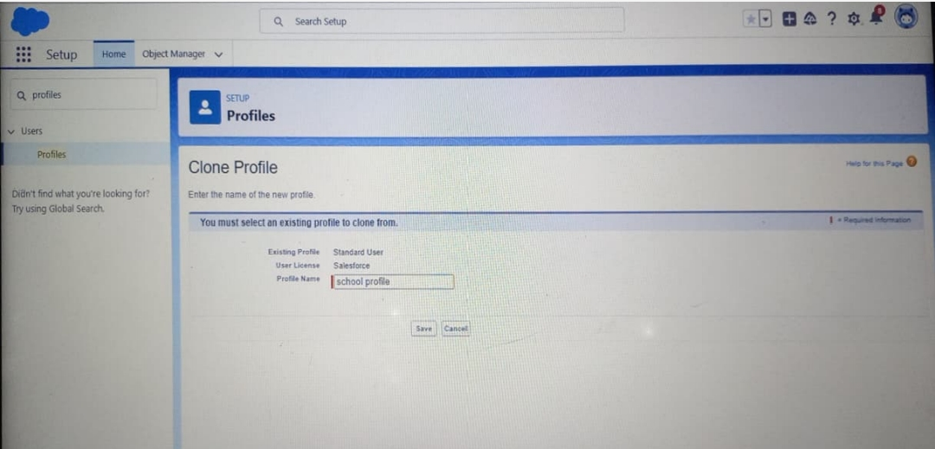

# MILESTONE-6:USER

# C:\Users\Admin\Downloads\Screenshot_2023-04-12-00-32-46-00_4a24d271e133915ae237d4bec6ffe368 (3).jpg

# MILESTONE-7:PERMISSION SETS

A Permission set is collection of settings and permission that gives users access to various tools and functions.Permission sets extend users functional access without changing their profiles.

## ACTIVITY 1:

##### PERMISSION SET 1:

TEACHER PERMISSION

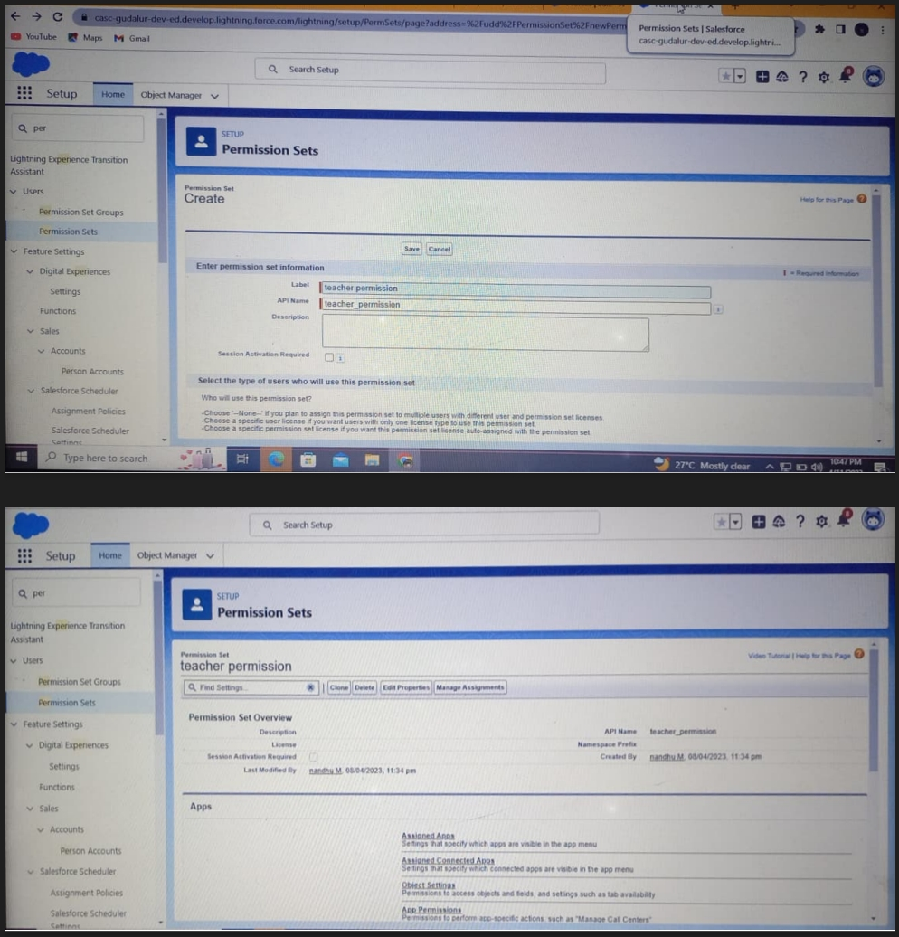

##### PERMISSION SET 2:

PRINCIPAL PERMISSION



# MILESTONE-8: REPORT

# C:\Users\Admin\Downloads\Screenshot_2023-04-12-00-33-42-19_e2d5b3f32b79de1d45acd1fad96fbb0f.jpg

# TRAILHEAD PROFILE PUBLIC URL:

## TEAM LEAD –https://trailblazer.me/id/sadap27

## TEAM MEMBER 1-https://trailblazer.me/id/sfaris20

# ADVANTAGES & DISADVANTAGES:

## ADVANTAGES OF CRM:

* Beneficial for the different department or teams of the business
* Customers are engaged across multiple channel
* Provide streamlined operations
* Improve customer service
* Helps in increasing sales
* CRM made targeting and marketing simple

## DISADVANTAGES OF CRM:

* A very costly project
* Loss of collected information r records
* Not suitable for every business
* It eliminates the human element
* CRM is not fully customized
* Third party access:

CRM data can be obtained and misused by other parties

# APPLICATIONS OF CRM:

### BANKING:

The banking sector in Malaysia greatly relies on using CRM software .The banking CRM solutions are designed to have more customer centric structures that is based on customer insight.

### HOTELS:

CRM is widely used in the hospitality sector,mainly in with the help of solutions helps are able to maintain databases of their guests and potential guests in an organized and accessible way.

### FINANCIAL SECTOR:

This industry is particularly privileged by the use of the effective CRM solutions.The new technology helps these business create targeted offers and identity high value customers .

### INSURANCE:

In the insurance industry,CRM solutions can act as a central hub that consolidate customer interactions from various channels an integrates data from multiple core insurance systems.

### AGRICULTURE:

A keep track the sales options, lacking into consideration the available logistics and transportation to destinations.

### CONSULTING:

By selecting an appropriate CRM, firms can effectively manage their daily tasks and better concentrate on serving their clients.

# CONCLUSION:

CRM is a must necessary tool for prospective organization makes our easy, secure and better way to understand the customers .We are CRM software development company that provides secure CRM software that comes with a data backup option and also we offer fall support from our expert team. Our team analyzes everything about CRM software that makes perfect CRM software.

# FUTURE SCOPE:

* More personalized customer experiences (according to a 2020 salesforce report,80% of the consumers say that the experience a company provides just as important as its products or services)
* Greater integration across all channels
* More advanced artificial intelligence capabilities
* More robust automation workflows
* More self-service options
* Increased adoption of a mobile CRM